📘 Assignment: IP Addressing

🔹 Task 1: Identify Your Device's IP Address
Objective: Find the IP address of your computer or mobile device and determine whether it is IPv4 or IPv6, and whether it is public or private.
Windows Command
Ipconfig
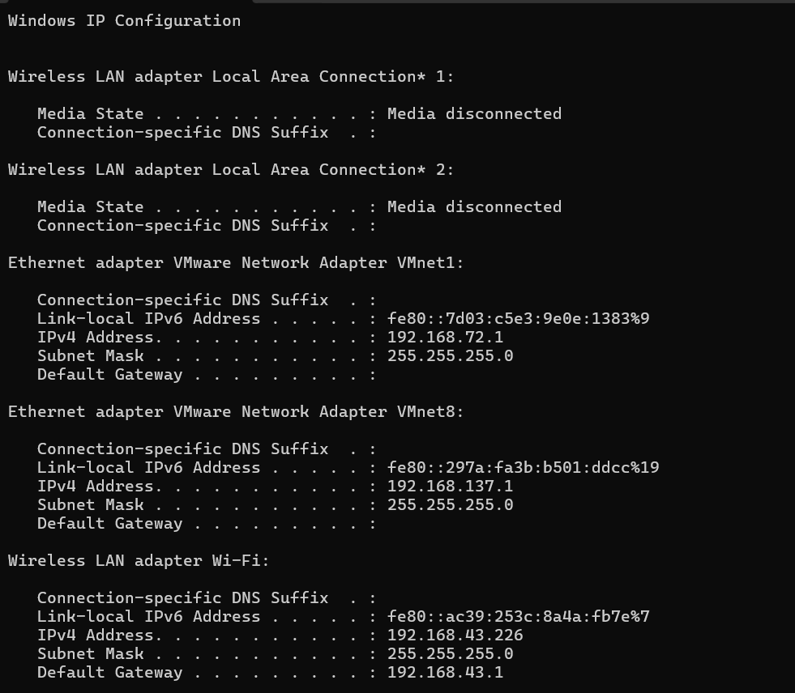

- IP Address: 192.168.43.226
- IP Version: IPv4
- Type: Private IP Address
Answer for your assignment
Device | IP Address | IP Version | Public or Private
Computer (Wi-Fi) | 192.168.43.226 | IPv4 | Private IP
Why is it a private IP?
The address 192.168.43.226 belongs to the 192.168.0.0 – 192.168.255.255 range, which is reserved for private networks. Private IP addresses are used within local networks (such as your home or office Wi-Fi) and are not directly accessible from the Internet.
Final Answer:
IP Address: 192.168.43.226
IP Version: IPv4
Type: Private IP Address
Task 2: Identify Private and Public IP Addresses
IP Address | Type | Reason
192.168.1.10 | Private | Falls within the private range 192.168.0.0 – 192.168.255.255
10.0.0.5 | Private | Falls within the private range 10.0.0.0 – 10.255.255.255
172.16.5.20 | Private | Falls within the private range 172.16.0.0 – 172.31.255.255
8.8.8.8 | Public | Public DNS server provided by Google
123.45.67.89 | Public | Does not belong to any private IP range

Task 3: Python Program to Validate an IPv4 Address
def is_valid_ipv4(ip):
parts = ip.split(".")
if len(parts) != 4:
return False
for part in parts:
if not part.isdigit():
return False
number = int(part)
if number < 0 or number > 255:
return False
return True
ip = input("Enter an IPv4 address: ")
if is_valid_ipv4(ip):
print("Valid IPv4 Address")
else:
print("Invalid IPv4 Address")
Example Output
Enter an IPv4 address: 192.168.1.10
Valid IPv4 Address
Enter an IPv4 address: 300.10.20.1
Invalid IPv4 Address

Task 4: How Instagram or WhatsApp Uses IP Addresses
Answer:
Applications such as Instagram and WhatsApp monitor IP addresses to help detect suspicious login attempts and improve account security.
Example Scenario
- A user usually logs into Instagram from Ahmedabad, India.
- Suddenly, another login attempt is detected from London, United Kingdom using a different IP address.
- Instagram identifies this as unusual activity because the login location is different from the user's normal behavior.
- The application may:
  - Send a login alert to the user's email or phone.
  - Request additional verification using Two-Factor Authentication (2FA).
  - Temporarily block the login until the user's identity is confirmed.
Benefits of Using IP Addresses
- Detects suspicious login attempts.
- Helps prevent unauthorized account access.
- Triggers additional security verification when necessary.
- Protects users from account hijacking and fraud.

